NATIONAL UNIVERSITY OF MODERN LANGUAGES ISLAMABAD



Software Design and Architecture

LAB MANUAL

**GROUP MEMBERS:**

Maheen Nasir (12315)

Hajra Muqddsa Akbar (12319)

**COURSE & SECTION:**

BSSE-4B

**SUBMITTED TO:**

Ms. Sadia Shabbir

**Date: 9-01-2022**

**LAB CONTENT**

|  |  |
| --- | --- |
| Lab 1 | Revision of uml concepts |
| Lab 2 | Comparison of tools and Working with Use Case Diagram |
| Lab 3 | Fully Dressed Casual and Two Column Format of Use Cases |
| Lab 4 | Uml Class Diagram |
| Lab 5 | Domain model |
| Lab 6 | Activity diagram |
| Lab 7 | System sequence diagram |
| Lab 8 | Sequence diagram |
| Lab 9 | Deployment diagram |
| Lab 10 | Design pattern |

**LAB NO. 1:**

**Lab Title: Revision of UML concepts**

**Question 1:**

**Draw an appropriate UML diagram for the below given scenario. Also give reasoning of choosing diagram.**

A university consists of multiple faculties. Each faculty is led by a dean, who is an employee of the university. There are many faculties and no of faculties have been known each employee has a job id, name, phone no, and email address. Two categories research and administrative personnel are differentiated according to their duties in the university. Research associative are assigned to at least one institute, each institute has its well-known field of study, which includes project of certain no. of hours, title of project, starting and ending date. Some search associates called lecturers holds courses. All the courses have a unique name, id, no. of hours allocated to them.

**Answer:**

**Why do we need class diagram for given scenario?**

Class diagrams are the blueprints of system or subsystem. We can use class diagrams to model the objects that make up the system, to display the relationships between the objects, and to describe what those objects do and the services that they provide. Class diagrams are useful in many stages of system design.

As class diagram are used to model the static view of the system so, as seen in above scenario it can be better approach to use object-oriented concepts to relate the given information with the help of classes.

In the given scenario there is an employee class generalized with dean class which is child class and inherits some attributes of parent class There are two subclasses named as faculty of engineering and faculty of arts associated with dean class.

Both classes have unique attributes as given in scenario and these are private. Another class which includes some properties and two methods research and administrative personnel are mentioned is associated with one of the child classes of dean. Other classes named as course and project are associated with subclass named as categories with some properties mentioned above.

**Class Diagram:**

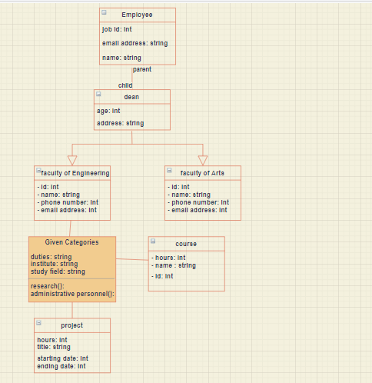

**Question 2:**

**Create a sequence diagram for following scenario of WhatsApp application**

* Creating a group on WhatsApp, sending the first message to the group, and checking status information of message sent.
* Sharing a picture and then a video from your gallery over your WhatsApp status and then checking who viewed your status.
* Creating and sending a new broadcast
* Do a video call to one of your WhatsApp contacts.

**Answer:**

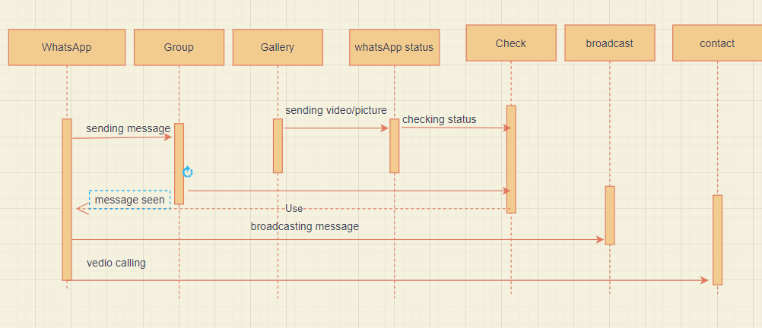

According given scenario, using sequence diagram at first the message is sent to WhatsApp group and then checked whether message has been reached or not.

Any picture or video is sharing from gallery to WhatsApp status and then checking who has seen it. Similarly, a message is broadcasted.

And doing a video call from WhatsApp to one of our contacts saved.

**LAB NO. 2:**

**Lab Title: Comparison of tools and Working with Use Case Diagram**

**Question 1**

Do a comparative analysis of UML tools

**Answer:**

|  |  |  |  |
| --- | --- | --- | --- |
| **reasons** | **Draw.io** | **Ms Visio** | **Smart draw** |
| language | Does not available in different languages | Does not available in different languages | Available in different languages so, user from different areas of the world can understand its working |
| Desktop application | It is Desktop application | It is Desktop application | It is Desktop application |
| usability | Easy to use for beginners because of less difficult features and | Widely used for business purpose | Widely used for business purpose |
| Online access | Provide facility to access and make diagram online | Does not provide facility to access online unless and until we download and install it on our PCs | Does not provide facility to access online unless and until we download and install it on our PCs |
| Variety of templates | It provides colorful template which attract the attention of users. | It also provides variety of templates. | It also provides variety of templates. |

**Question 2:**

Which diagrams come under static and dynamic UML diagrams also give reasoning

**Answer:**

**Static diagrams:**

1. Class Diagram

Why class diagram is said to be static diagram?

* In UML class diagram represent the static aspect of system.
* static aspects represent those parts of a diagram, which forms the main structure therefore they are stable.
* Class diagrams basically represent the object-oriented methodology of a system, which is static in nature.
* it is generally used for development purpose. This is the most widely used diagram at the time of system construction.

**Dynamic Diagrams:**

These diagrams show dynamic behavior of system.

1. Activity Diagram
2. Use case Diagrams
3. Sequence Diagram
4. State Machine Diagram

* **Why Activity Diagram is dynamic in nature?**
* It is a graphical representation that shows workflow in stepwise activities.
* The control flow is drawn from one operation to another.  Activity diagram deals with all type of flow control by using different elements such as fork, join, etc.
* **Why Use case Diagram is dynamic in nature?**
* Use case diagram is to capture the dynamic aspect of a system.
* It helps in understanding how a user might interact with the system.
* A single use case diagram captures a particular functionality of a system.
* **Why Sequence Diagram is dynamic in nature?**
* It focuses on lifeline or processes and objects that live simultaneously.
* Messages are exchanged between objects to perform a function before the lifeline ends.
* It shows interaction between group of objects.
* **Why State Machine Diagram is dynamic in nature?**
* **State Diagram** are used to capture the behavior of a software system.
* State chart diagram/ state machine diagram is used to capture the dynamic aspect of a system.
* An object goes through various states during its lifespan. The lifespan of an object remains until the program is terminated.
* The object goes from multiple states depending upon the event that occurs within the object.
* Each state represents some unique information about the object.

**Question 3:**

**Consider following scenario**

At the beginning of each semester students may request a course catalogue from registrar containing a list of course offering for the semester. Information about each course, such as professor, department and prerequisites will be maintained by registrar to help students make informed decisions. The new on-line registration system will allow students to perform registration and select four course offerings for the coming semester. In addition, each student will indicate two alternative choices in case a course offering becomes filled or canceled. No course offering will have more than ten students. No course offering will have fewer than three students. A course offering with fewer than three students will be canceled. Once the registration process is completed for a student, the registration system sends information to the billing system, so the student can be billed for the semester. Professors must be able to access the on-line system to indicate which courses they will be teaching. Professors will also need to view course offering roster to see which students signed up for their course offering. For each semester, there is a period of time that students can change their schedules. Students must be able to access the on-line system during this time to add or drop courses. The billing system will credit all students for courses dropped during this period of time. The registrar would also maintain course curriculum and update it in the system

**Q1 Identify primary and secondary Actors of the system**.

**Primary Actors:**

* Student
* Professor
* Registrar

**Secondary Actors**:

* Registration System
* Billing System

**Q2 Create actor goal list for above scenario**

|  |  |
| --- | --- |
| **Actors** | **Goals** |
| Student | Requestcourse catalogue, select four courses, may change their schedule in specific period of time, can access online system to add and drop courses |
| Registrar | Maintain information about courses, professor and department, maintain and update course curriculum |
| Professor | Access online system to know which course they teach, view course offering roster |
| Registration system | Allow student to perform registration, send information |
| Billing System | Receive information, billed student for semester, credit all students for courses dropped |

**Q2 Identify Use Cases that appears as verbs.**

**Q3 Use Include and Extend relationship where needed**

**Q4 Draw a complete Use Case diagram of the system**

**Answer:**

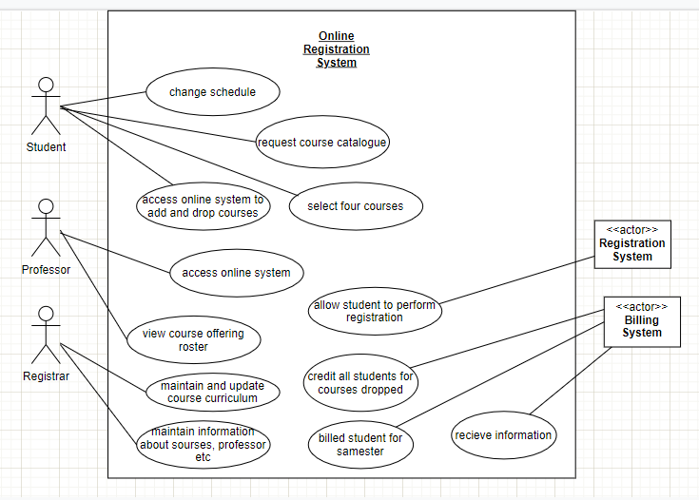

**LAB NO. 3:**

**Lab Title: Fully Dressed Casual and Two Column Format of Use Cases**

**Q1.**

Consider following scenario and identify at least 5 use cases. Among 5 use cases two of the use cases should be described by using the fully-dressed format and the casual format can be used for the rest of the use cases Online Bookstore System on a Cloud Platform This project aims to develop an online bookstore system that acts as a central database containing various books in stock along with their title, author's name, published date, and cost. This project, basically a website, will get a large amount of online visitors. The system should be hosted on a cloud platform in order to avoid site crash. The project can be developed using Java (front end support) and SQL (back-end support). The online bookstore stores various book related details. Microsoft Azure can be used for cloud-based infrastructure. The user will be able to login, view a wide range of books arranged in respective categories, select desired book and view its price, Check the availability of the book, Search for specific books on the website, reserve a book by filling-in a form, See the due date (25 days from the date of issuance.), Get a reminder once they cross the due date of submission of a book.

**Answer:**

**Use cases:**

1. Login

2. Select book

3. Check availability of books

4. Reserve book

5. Get reminder of due date

|  |  |
| --- | --- |
| **System** | **Online Bookstore** |
| **Use case name** | UC4: reserve a book |
| **Brief**  **Description** | In online bookstore customer reserve a book of his choice by providing necessary information asked by system. |
| **scope** | People are facilitated to buy book of their interest and get it at place where they want |
| **actor** | Primary: customer, secondary: book store |
| **Pre-condition** | Customer registered himself by providing necessary information which is asked by website to login into online bookshop system. |
| **Post condition** | Book is selected. Customer purchased or reserve it for few days. |
| **Main success scenario** | 1. Customer login to website of online bookshop 2. he views categories where books of different subjects are placed. 3. He selects category where many books on one subject or topic are placed. 4. Customer may search book by book name or author name or both 5. Customer provide author or book name to search out book of interest. 6. Customer see price and select book. and reserve book among various books. 7. Book details are recorded by system. 8. If customer purchase book then he may pay amount using recommended ways (using credit card, debit card, easy paisa on cash on delivery). |
| **Alternative1a scenario** | 1. If customer forget password, system should provide facility of re-entering password. 2. Or he may asked by system to reset password to get access to bookstore. |
| **Alternative2a scenario** | 1. If list of categories not shown on portal, then user may ask to system to show books of his interest. |
| **Alternative4-5** | 1. If customer forget author name, then he can only enter book name to get book and if he forgets book name then he may get book by author name. 2. If he forgets both then he should be given facility by system to randomly select and reserve book from given categories of books. |
| **Alternative6a** | 1. If price is not shown on portal, then customer is given facility to ask about price before reserving book. |
| **Assumption** | User want to reserve book in online bookshop. |
| **Special requirement** | The personal information provided by customer for registration should be encrypted.  The system should show efficient response and not get slow when many customers join simultaneously. |

|  |  |
| --- | --- |
| **System** | **Online Bookstore** |
| **Use case name** | UC3: Check availability of books |
| **Brief**  **Description** | In online book store system customer login to view a wide range of books and Check the availability of book of interest. |
| **Scope** | The System has a great future scope, Customer can visit and check his book of interest it reliable and easy to visit book store from home. |
| **actor** | Primary actor : Customer Secondary actor : Book store |
| **Pre-condition** | Customer enters the ID and password to login and proceeded to check availability of book on online store |
| **Post condition** | Book has been found and customer purchased it |
| **Main success**  **scenario** | 1. Customer visit book store and view books 2. Search a book of interest 3. Purchased it and leave a store |
| **Alternative scenario 1a-2a** | 1. website not working properly due to lack of resources and send message to customer that he will not able to access website 2. if customer is entering wrong password send a message invalid login |
| **Alternative scenario 2a** | 1. if customer not find a book then send message to customer book is not available |
| **Alternative scenario 3a** | 1. if customer is not able to pay a bill send message to customer payment failure |
| **Assumption** | Customer want to Check the availability of book |
| **Special requirement** | The personal information provided by customer for registration should be encrypted. |

**Casual format of use cases:**

**UC-01:**

|  |  |
| --- | --- |
| **Name** | **Login** |
| **(Main success scenario)** | A customer or user can register by providing necessary information which includes user name, password, email id and email id password. All the information is taken again in same login page for confirmation and security purpose i.e., in order to check correct person wants access. If a new user wants access to system, he has to form account to get access. By providing correct information system allow user to access its command. |
| **Alternative 1** | In any case if user fails to login in system by providing incorrect data, system will give another chance of reentering data. |
| **Alternative 2** | If user forget password, the system allow user to select option of ‘forget password’ and then he can form new password. |

**UC-02:**

|  |  |
| --- | --- |
| **Name** | **Select a book** |
| **Main success scenario** | User or customer vies list of all categories of book. then user select category related to book which he wants to purchase. In that category he views book. user can search book by writing book name in search bar. user select book of interest and will write book detail to keep record for system. |
| **Alternative 1** | If lists are not shown then user will have to choose book placed randomly. |
| **Alternative 2** | User must be given option either search book by book name or author name for ease. |

**UC-05:**

|  |  |
| --- | --- |
| **Name** | **Give reminder of due date** |
| **Main success scenario** | User reserve book by filling a form which includes detail about book which includes book name, author name, book id, book category, user name, email, phone number, date of issuance and due date of returning book. if user not return book on due date or he forgets to return then system send message for resubmission of book on email or phone number. User must pay fine if book is not returned on due date. |
| **Alternative 1** | Message of returning book must be sent two days before due date for remaindering. |

**Q2**:

Consider an automated student registration system which requires student to login as well as provides registration to students. It also enables student to enroll in courses. The student can enroll in only those classes that are part of their degree fully dressed use case in two column formats for following use case “Enroll in a course” Answer:

|  |  |
| --- | --- |
| UC-01 | Enroll in a course |
| Actor | student |

Goal

Student will get enrolled in courses which are related to degree

Pre

-

requisite

student must be login to system by

providing necessary detail and

should be registered one.

User action

•

Student search courses

•

Student select courses

which are related to

degree

.

•

Student perform

registration to get

enr

ollment in selected

courses

System response

•

System shows various

course list and allows

student to search from

list

•

System shows those

courses which are

selected by student

•

System register student

and enroll student in

selected courses.

alternate

If student cannot find courses of interest, then he may ask to

system

about courses.

**LAB NO. 4:**

**Lab Title: Uml Class Diagram**

**Question 1:**

Draw a class diagram for a scenario of a test system. The process flow is outlined below. Use association according to your own understanding

**i. Students attend Classes;**

**ii. Teachers mark attendance;**

**iii. Teachers prepare test papers;**

**iv. Students write test papers;**

**v. Teachers check test papers;**

**vi. Teachers declare results;**

**Answer:**

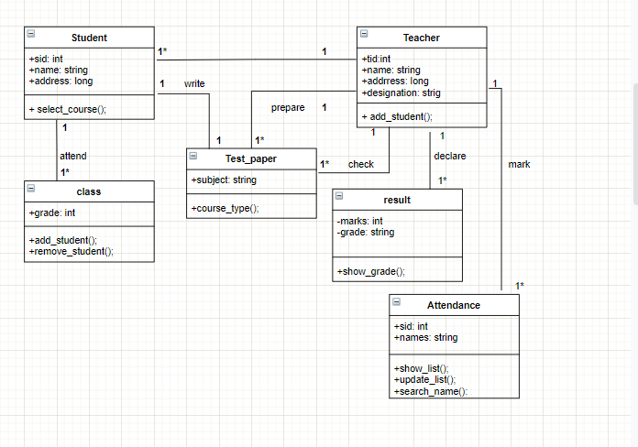

**Noun:**

* Student
* Name--- attribute of student
* Id—attribute of student
* Address--attribute of student
* Classes
* attendance
* Teacher
* Name-- attribute of teacher
* Id-- attribute of teacher
* Address-- attribute of teacher
* Designation-- attribute of teacher
* Teachers—redundant
* Test paper
* Test paper—redundant
* result

**Question 2:**

A company has a number of employees. The attributes of Employee include employee ID (primary key), name, address, and birth date. The company also has several projects. Attributes of Project include project ID, project name and start date. Each employee may be assigned to one or more projects, or may not be assigned to a project, a project must have at least one employee assigned, and it may have any number of employees assigned. As employee's billing rate may vary by project, and the company wishes to record the applicable billing rate for each employee when assigned to a particular project. At the end of each month, the company mails a check to each employee who has worked on a project during that month. The check amount is based on the billing rate and the hours logged for each project assigned to the employ

**Answer:**

**STEP 1:**

**Nouns:**

Company—irrelevant class

employee -- class

project---- class

billing_rate----class

employee_id-- attribute of employee

name: attribute of employee

address: attribute of employee

birth rate: attribute of employee

project_id: attribute of project

project_name: attribute of project

start date: attribute of project

employee—redundant class

project—redundant class

check_mail-- operation

**STEP 2:**

**Redundant classes:**

Employee

Project

**Attributes:**

* employee ID (primary key), name, address, and birth date for **class Employee**.
* project ID, project name and start date for **class project.**
* Hours_logged, project_type, project_date

**Operations:**

Check_mails(), record_billing_rate(), check_amount():

**Diagram:**

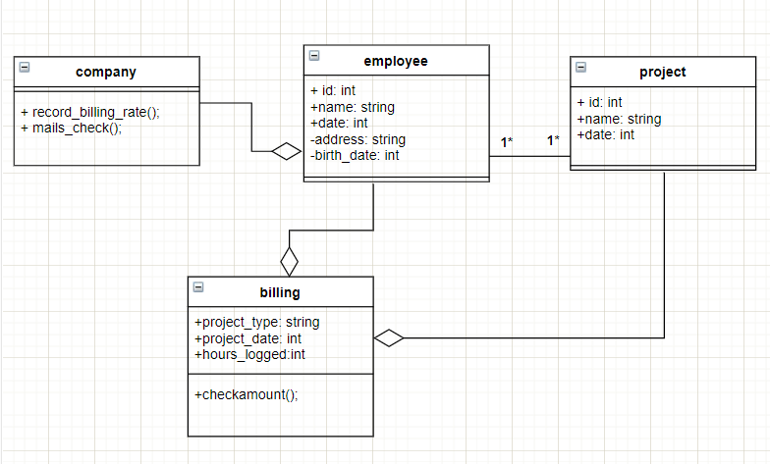

**LAB NO. 5:**

**Lab Title: Domain Model**

**Q1**

**Consider a school management system. Draw a domain model for this scenario and identify conceptual classes by using following conceptual class category list i.e taught in lecture**

|  |  |
| --- | --- |
| **Conceptual Class Category** | **Example** |
| Business Transaction | Billing , Fee |
| Transaction line item | Billing line |
| Product or service | Books , uniform , transport |
| Where is transaction recorded | Acquaintance roll, Contingencies and fee collection register, Ledger |
| Roles of people or organization | Student, Teacher, Owner, Administrator |
| Noteworthy events, often with a place or time we need to remember | Academic performance,  Students achievement and Grades, Extracurricular performance |
| Physical objects | Building, Office space , Equipment in library and laboratory, Furniture, vehicles |
| Description of things | Fee , salary , scholarships description |
| catalogue | Course Catalogue, Fee  Catalogue, Attendance  Catalogue |
| Container of things (physical or informational) | School |
| Things in container | Student , Teacher, Admin |
| Other collaborating system | Examination Board |
| Record of finance, work, contract, legal matters | Acquaintance roll, Contingencies and fee collection register, Ledger |
| Financial instrument | Credit, Cheque, Cash |

**Diagram:**

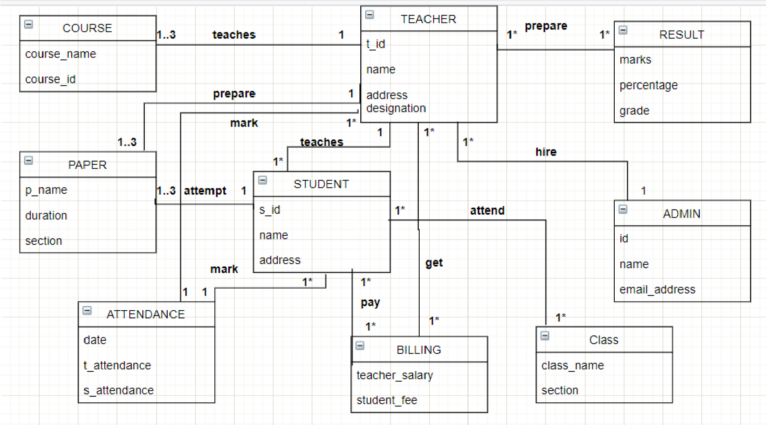

**Q2**

Consider the following use case and develop a Domain Model using a noun phrase identification technique to represent the relevant conceptual classes with attributes and the association between them.

Title: Deposit Money in ATM

Primary Actor: Customer

Main Scenario: The Customer approaches the Bank's ATM

The customer inserts his/her card

The ATM requests the customer's PIN

The customer enters his/her PIN

The ATM validates the customer's details

The ATM displays a list of actions

The customer selects deposit

The ATM requests the money be inserted

The customer inserts the money in the ATM

The ATM adds up the money inserted and asks customer to confirm total

The customer confirms the total

The ATM updates the balance of the customer's selected account

The ATM returns the customer's card.

**Nouns:**

Money, customer, bank, ATM, atm card, balance, account.

**Diagram**

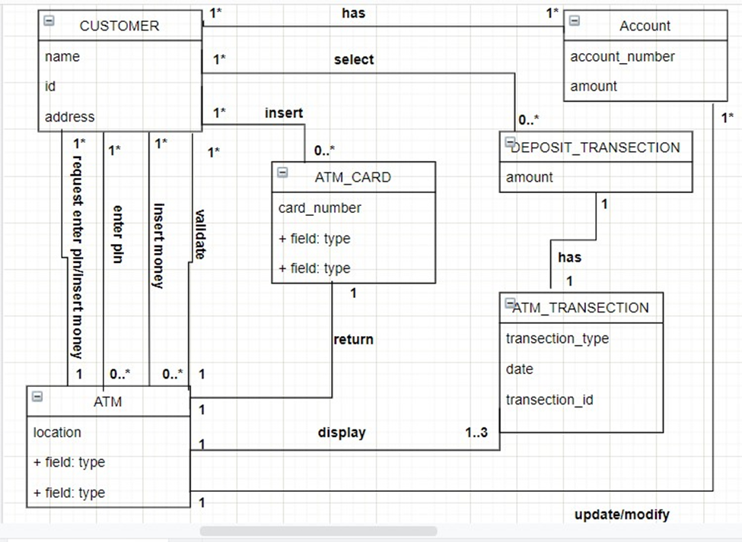

**LAB NO. 6:**

**Lab Title: Activity Diagram**

Q1. Draw an activity diagram for following scenario;

Consider developing a new online attendance system to be for a university. The steps of the activity diagram are as follows: (You have to follow every step to create the complete activity

Diagram)

1. The faculty is asked to first enter valid username and password in the system
2. If an invalid username or password is entered, a message is displayed that faculty has entered wrong username or password
3. if valid user name or password is entered, the form depicting the course name, course id and list of students are displayed the form also displays week number and session number
4. If the faculty selects any invalid session (more than session 3), an error message is displayed
5. After the faculty has completed with the attendance, he/she saves the attendance. Upon saving the attendance, a message is prompted whether the user is sure to save the attendance. If the faculty selects yes, attendance is saved and the home page is displayed to the user

(f) If the faculty selects no, the entire process is repeated Diagram:

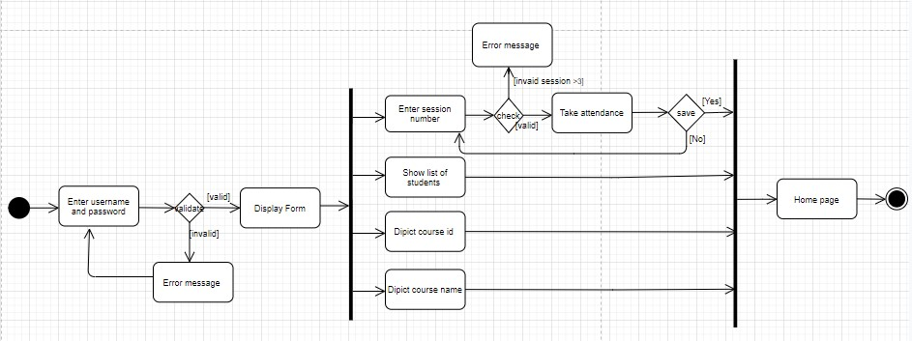

Q2. Draw an activity diagram with swim lanes for following scenario;

The author submits a paper to an editor of a journal. The editor first checks whether the paper fit the theme of the journal. If not, the editor rejects the paper. Otherwise, the editor assigns the paper to several reviewers. The reviewers review the paper and write a review. The review is sent to the editor. The editor then assesses the quality of the paper with the help of reviewers' comments. If the quality is good, the paper will be accepted, and the author notified. Furthermore, the paper is forwarded to the publisher for publication. If the quality is bad, the editor rejects the paper.

**Diagram:**

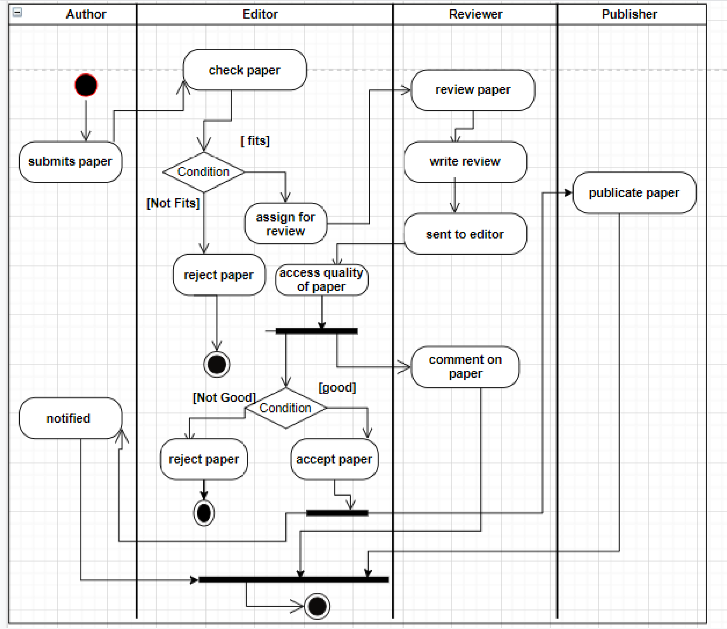

**LAB NO. 7:**

**Lab Title: System Sequences Diagram**

**Question 1:**

You have been asked to develop a system for a local Thai food takeaway shop named ABC. The system should allow customer to order their Thai curriers over the internet and collect them and pay at the shop. Customer do not register with the system but they need to supply a contact phone number. ABC has a price derived from its size, type (red, green or yellow) and protein A curry has only one protein (chicken, beef or pawn). Each type of protein has different price. Customer have orders and each order is for one customer. An order consists of number of items, and has a collection time. An item is a curry, rice or drink. To place an order a customer must supply a contact phone number and name. a person can order multiple items. When order is submitted the customer receives a confirmation message along with the final cost of an order and collection time. The system calculate the collection time based on the number of orders currently being processed and average time to fil an order. Once payment receipt is generated the system won’t allow customer to change or cancel his order.

**Use case :-**

**Pay bill :-**

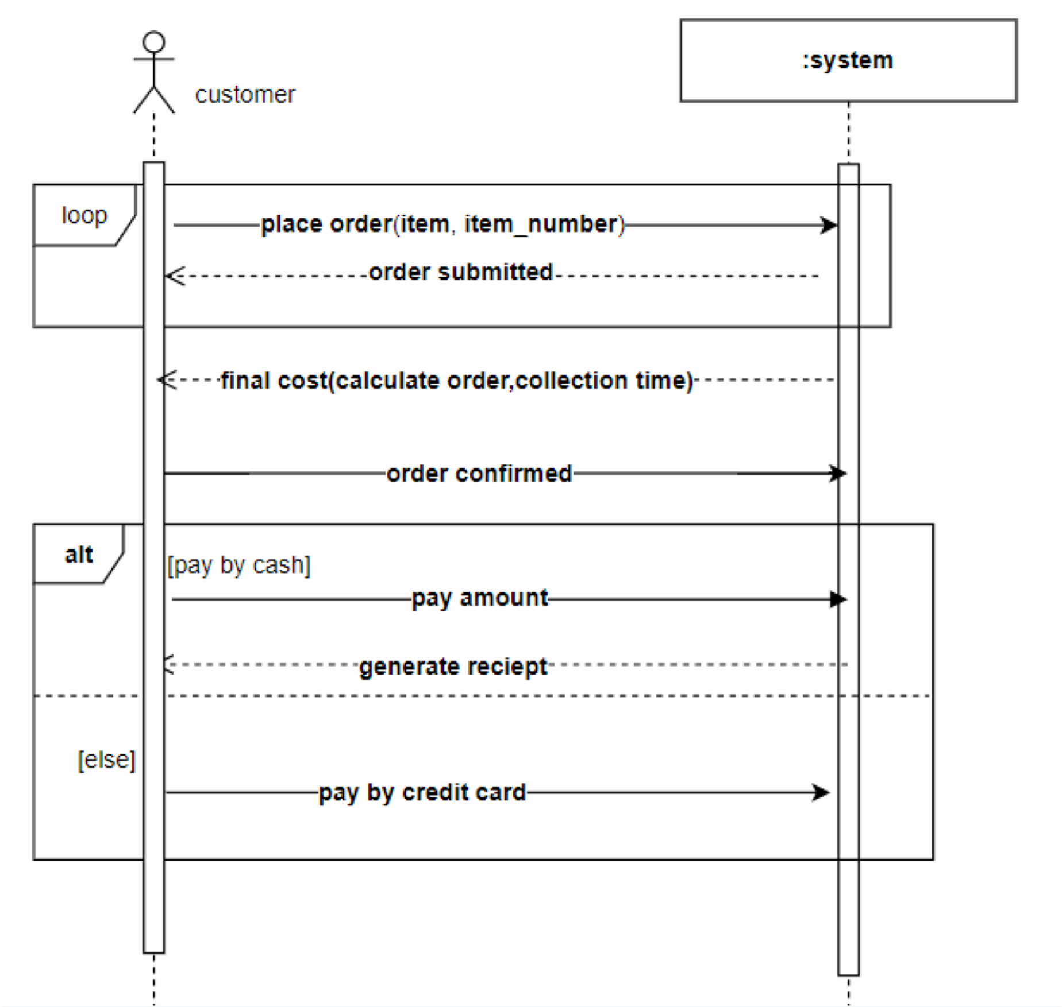

**Question 2:**

Draw SSD of any two use cases of social networking website.

**Use case 1 :-**

**Create profile:-**

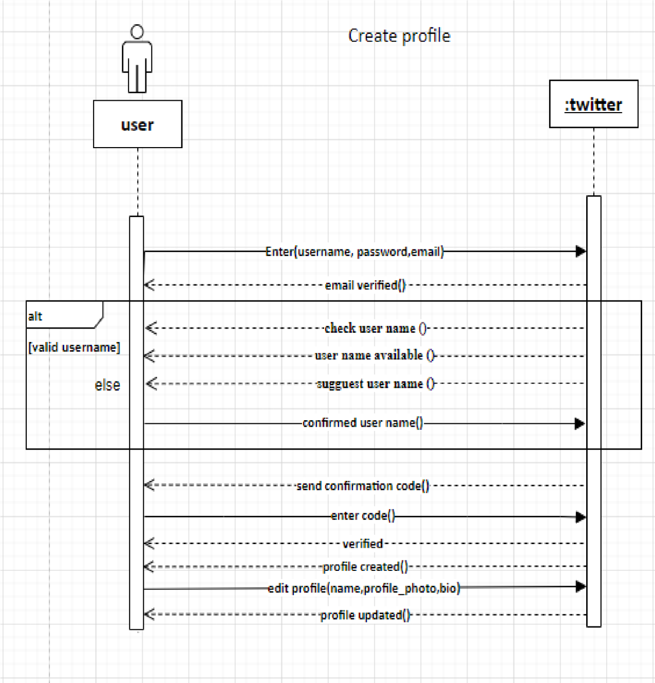

**Use case 2 :- Following user**

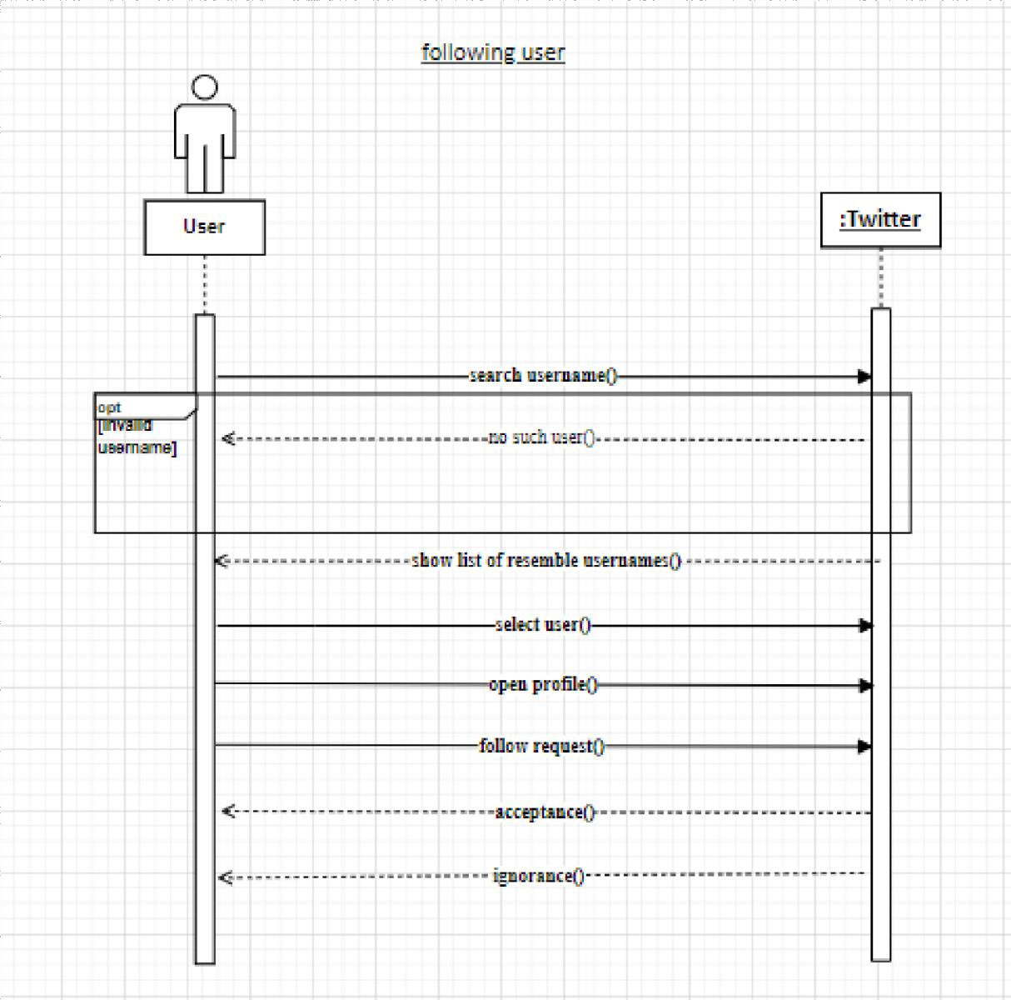

**LAB NO. 8:**

**Lab Title: Sequences Diagram**

**Question no. 1:**

Draw a sequence diagram with the following scenario statements

➢ Firstly, the application is opened by the user.

* The device then gets access to the web cam.
* The webcam captures the image of the user.
* The device uses algorithms to detect the face and predict the mood.
* It then requests database for dictionary of possible moods.
* The mood is retrieved from the database.
* The mood is displayed to the user.
* The music is requested from the database.
* The playlist is generated and finally shown to the user.

**Diagram:**

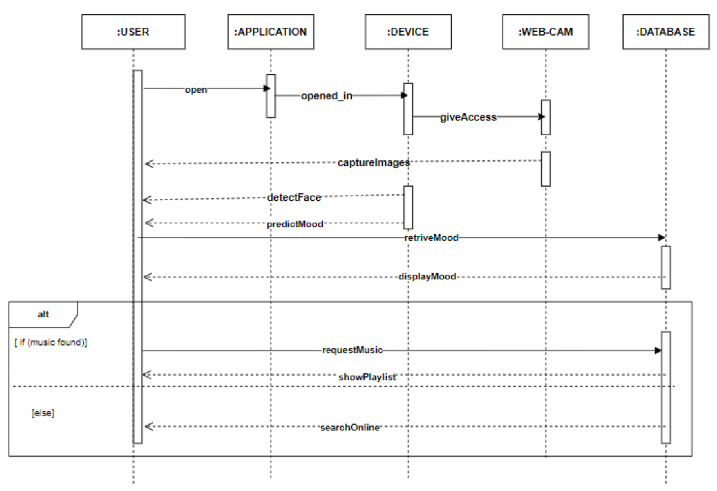

**Question no.2:**

Draw a sequence diagram for following scenario

• A student would like to book a laboratory session slot for his/her practical class. The scheduler will check for a free slot. If there is a free slot, the student will be accepted. The student will be assigned to a specific slot in the schedule. The student will be notified with a confirmation message. If there is no free slot available in the system, a message will be prepared by the scheduler and the notification will be sent to the student. The initial message login will be originated from the user interface and send to the scheduler.

**Diagram:**

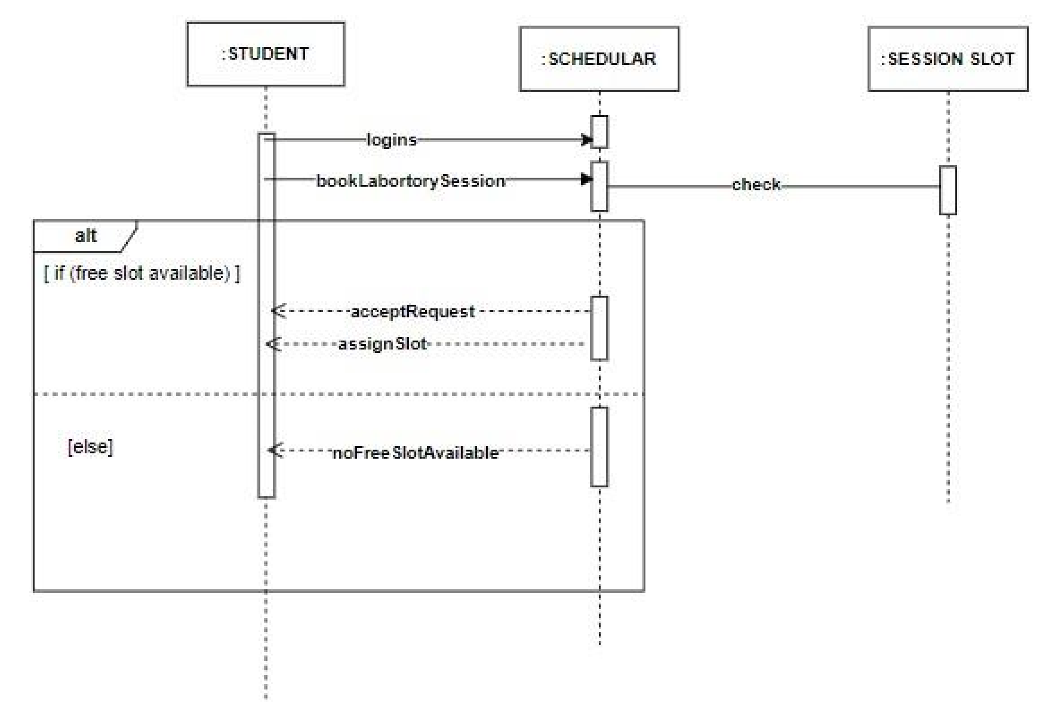

**Question no : 3**

Sequence diagram for food panda application.

**Diagram:**

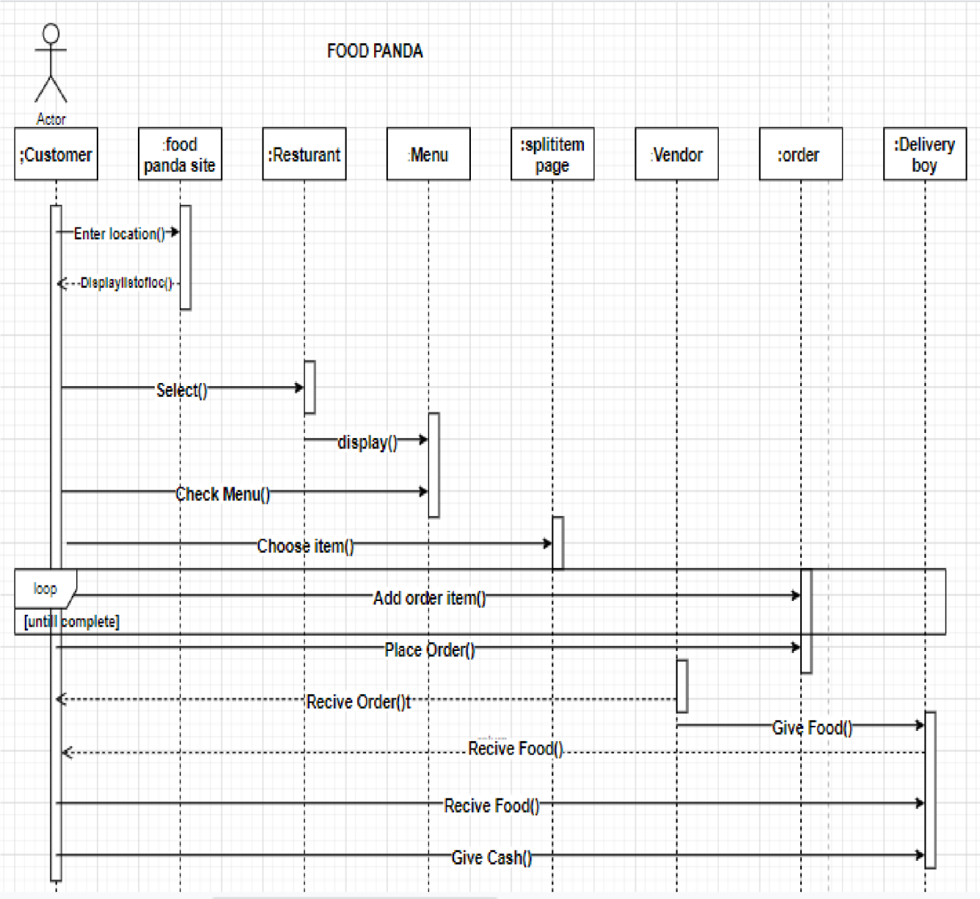

**LAB NO. 9:**

**Lab Title: Deployment Diagram**

**QUESTION 1:**

Library Management System (LMS) is library management software for monitoring and controlling the transactions in a library. LMS gives us complete information about the library and the daily transactions done in a Library. LMS maintains the details of books available in the library. LMS mainly focuses on basic operations in a library like adding a new member, new books and updating information on existing books. LMS also provides the facility of search books, search members, borrow books and return books. Following systems are required to deploy LMS system in a real environment. Local Consoles Computers for login and search purposes by users, librarian and vendors. Library LAN Server interconnects all the systems to the Database. Internet provide access to Vendors to supply the requested books by the Librarian Vendor Server maintains the records of the requests made by the librarian and books provided to the library. Question:

* Draw the UML Deployment diagram for the system mentioned above.

**ANSWER:**

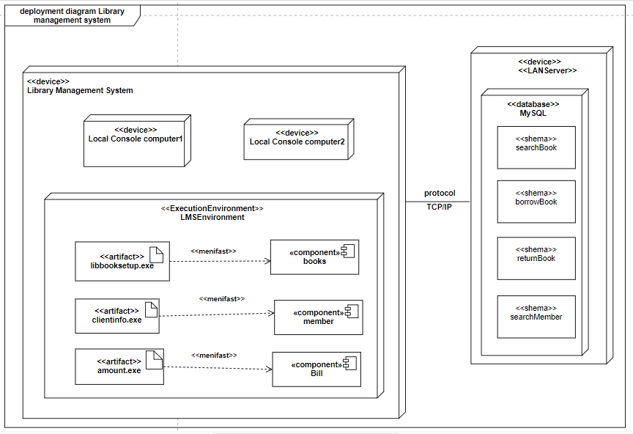

**QUESTION 2:**

Consider any software you have developed so far and create deployment diagram for it.

**ANSWER:**

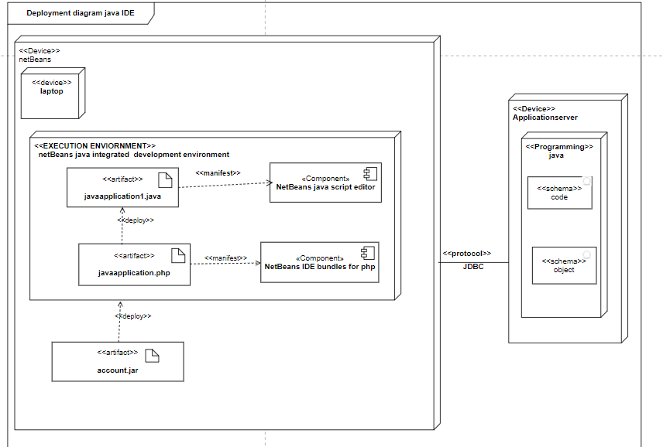

**LAB NO. 10:**

**Lab Title: Design Pattern**

**Question 1:**

Draw abstract factory pattern

**Diagram:**

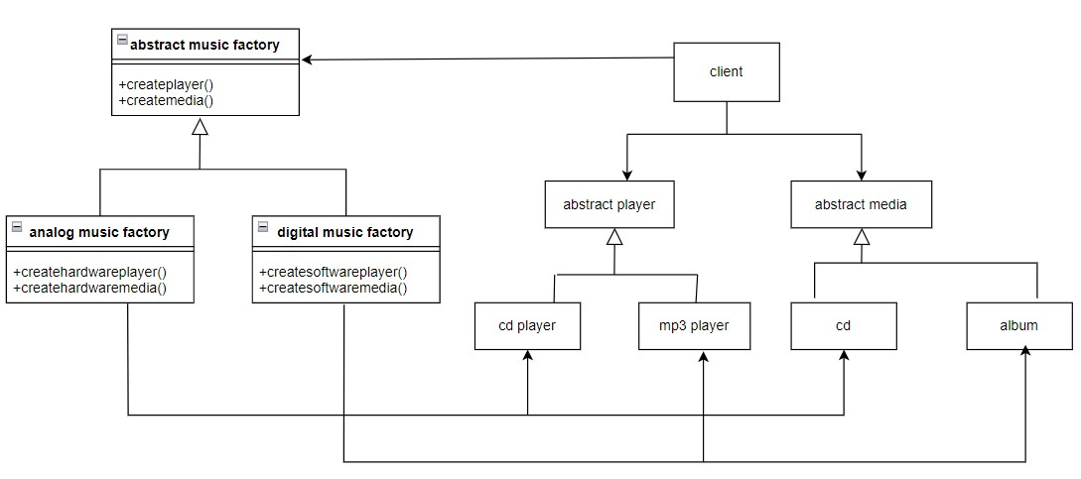

**Question 2:**

Draw pattern which you think java programming language has.

**Diagram:**

* We used decorator creational pattern;

